**ABSTRACT**

The identification, segmentation, and detection of the infected area in brain tumor is a tedious and a time-consuming task. The different structures of the human body can be visualized by an image processing concept, an MRI. It is very difficult to visualize abnormal structures of the human brain using simple imaging techniques. An MRI technique contains many imaging modalities that scan and capture the internal structure of the human brain. This article concentrates on a noise removal technique, followed by improvement of medical images for a correct diagnosis using a balance contrast enhancement technique (BCET). Then, image segmentation is used. Finally, the canny edge detection method is applied to detect the fine edges. The experiment results achieved nearly 98% accuracy in detecting the area of the tumor and normal brain regions in MRI images demonstrating the effectiveness of the proposed technique.

**Algorithms:**

* Adaptive Median Filter (AMF)
* Balance Contrast Enhancement Technique (BCET).
* Fuzzy C-Means Clustering
* Thresholding
* Canny Edge Detection

**Existing System:**

Digital image processing consists of algorithmic processes that transform one image into another in which certain information of interest is highlighted, and/or the information which is irrelevant to the application is attenuated or eliminated. The majority of hospitals use digital technology system to support their work because the system can bring users many benefits. The diagnosis result is dependent on the medical image because doctors often use the image to find out medical problems for patients. Based on the information from the image, especially object boundaries doctors will build a suitable treatment plan to save their lives. In fact, many patients are died by inaccuracy in diagnosis, which comes from a lack of information in the image because the image has not been processed effectively. And the edge detection is one of the important fundamental tools in image processing, particularly in the areas of feature detection and feature extraction, which aim at identifying points in a digital image at which the image has discontinuities.

**Proposed System:**

A brain tumor is a collection of abnormal cells in the brain. A tumor may lead to cancer, which is a major leading cause of death and responsible for around 11% of all deaths worldwide. The cancer incidence rate is growing at an alarming rate in the world. So, detection of the tumor is very important in earlier stages. This paper tries to solve the problem of how to make a clearer area for tumor cells of the brain and the area which contains the normal brain cells of MRI image with a minimal number of configurable parameters dependable on the input image. Thus, the researchers propose a set of computational procedures for image preparation for further analysis by medical specialists. In this set, two main components can be distinguished: improvement of image quality and segmentation of objects of interest (brain tumors and area of brains in the MRI images) with the formation of an edge map.

**System Architecture:**

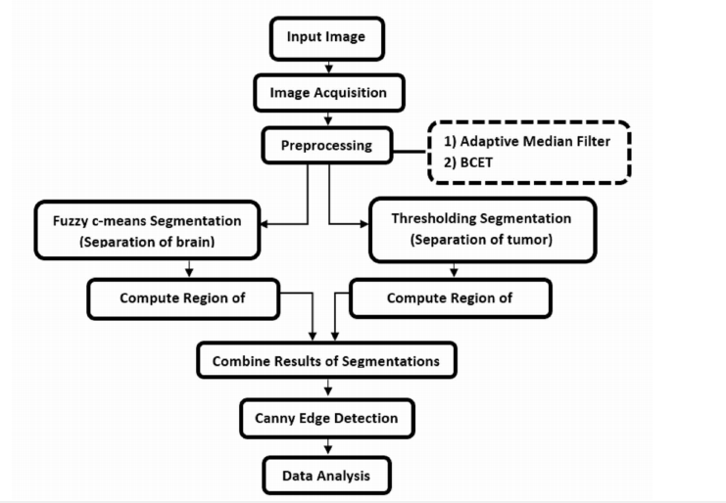

**Modules:**

**Image Acquisition:**

In this system suggested approach the authors first believed that the MRI scan images of a given patient are either color, Grayscale or intensity images herein are displayed with a default size of 256×256. If it is a color image, a Gray-scale converted image is determined by using a big matrix whose entrances are numerical values between 0 and 255, where 0 represents to black and 255 to white for illustrating. Then the brain tumor detection of a given patient constitutes three main stages namely, preprocessing, image segmentation and contour representation.

**Preprocessing:**

The authors suggested an adaptive median filter to remove noise from an image, since it is better among all the spatial filters and distinguish fine details from noise. The Adaptive Median Filter performs spatial processing to determine which pixels in an image have been affected by impulse noise. Also, the Adaptive Median Filter (AMF) classifies pixels as noise by comparing each pixel in the image to its surrounding neighbor pixels. The size of the neighborhood is adjustable, as well as the threshold for the comparison. A pixel that is different from a majority of its neighbors, as well as being not structurally aligned with those pixels to which it is similar, is labeled as impulse noise. These noise pixels are then replaced by the median pixel value of the pixels in the neighborhood that have passed the noise labeling test. We are initially converting the image into a grayscale image using rgb2gray () function then applying adaptive mean filtering to the resulting image and then converted the image into unsigned integer 8 using unit8() function. To improve the contrast for highlighting the area of interest the researchers proposed to use Balance Contrast Enhancement Technique (BCET). Typically, during medical image processing, the contrast enhancement is required for the area of interest.

**Segmentation:**

Medical image segmentation for detection of brain tumor from the magnetic resonance (MR) images or from other medical imaging modalities is a very important process for deciding right therapy at the right time. The result of image segmentation is a set of regions that collectively cover the entire image or a set of contours extracted from the image. Each of the pixels in a region is similar with respect to some characteristic or computed property, such as color, intensity, or texture. Thresholding technique segments the MR images by a binary partitioning of the image intensities. The segmentation is a process where the image is partitioned into different regions. After image enhancement, preliminary segmentation of the medical image determines the boundaries of the area of interest most accurately. To perform the segmentation, the Fuzzy C-Means (FCM) clustering and thresholding methods were chosen. The Fuzzy C-Means segmentation used to segment the region of the normal brain, and the thresholding segmentation is converting the enhanced image to binary image to segment the region of the tumor (shape, area, spatial sizes, etc.) in MRI images.

**Contour Representation:**

The contour map can be generated with canny edge detection algorithm. The Canny edge detector is the most effective detectors from several edge detection operators in the image processing field. It is able to perceive an extensive range of edges in an image. After splitting the image into a series of homogeneous classes using the FCM clustering and thresholding algorithms, the canny edge detector is applied. It is based on the gradient value of a pixel and is used to determine fine edge, while the image includes homogeneous regions.

**SYSTEM CONFIGURATION:**

**Hardware requirements:**

Processer : Any Update Processer

Ram : Min 4 GB

Hard Disk : Min 100 GB

**Software requirements:**

Operating System : Windows family

Technology : Python 3.6

IDE : PyCharm